|  |
| --- |
| **PE075DS (13) Report on Front-end Web Development Project 前端網站開發人員證書 - 網站開發專案** |

**Project Team Members**

|  |  |  |
| --- | --- | --- |
| Lo Ka Man | 羅家文 | (2) |
| Heung Chee Leung Ivan | 香志良 | (6) |
| Chan Chun Hei | 陳俊羲 | (18) |
| Lam Tai Yuen | 林大源 | (19) |
| Tsan Siu For | 湛兆科 | (24) |

1. **Background**
2. **Project Requirement**

* eCommerce Website with Front-end Capabilities
* To plan, design, and develop a business website of 15 pages or more, and implement front-end functions.
* All data needs to be connected to the server to get it from the database.
* This website must be developed using application technologies such as HTML, CSS and JavaScript to ensure proper functioning.

1. **Project Objective**

* Project Objective – to construct a website which is user-friendly, responsive, reliable; enhance customer experience; ensure maintainability, scalability for future growth and continuous improvement.

1. **Project Planning**

* Major Project Phases –
* Design – website architecture, structure, webpages, screen flow
* Development – coding and integration
* Testing and Refinement
* Development Tools -
* HTML - use Visual Studio code to support HTML coding on webpages
* CSS - use CSS and Bootstrap to set style, formatting and responsive design of webpages
* JavaScript - use JavaScript to support data extraction and interactive elements of webpages
* GitHub – use for web page code sharing, website review and testing

1. **Project Details**
2. **Background**

**Trends**

* The pandemic accelerated online shopping, with more consumers turning to eCommerce for eyewear purchases.

**Benefits**

* The convenience of online shopping has revolutionized the way we purchase goods, including Eyeglasses.
* One of the biggest advantages of buying online is convenience. You can shop at any time, from anywhere, without the need to visit a physical store. This is particularly beneficial for busy individuals who may not have the time to schedule an appointment or for those living in remote areas where access to optical stores is limited. Online shopping also allows you to browse a vast selection of frames and compare prices across multiple retailers in just a few minutes.
* When it comes to price, online retailers often have the advantage. Lower overhead costs mean that online stores can offer products at significantly reduced price, some of them also frequently run promotions and discounts. Additionally, online platforms often offer a wider range of prices, from high-end products to more affordable alternatives.
* Many of the online retailers are increasingly offering customizable options, improve customer service by allowing customers various choices for their selection.

1. **Products and Services Description**

* Product: Optica Eyeglasses
* Premium Quality: Lightweight frames and high-quality lenses for durability.
* Stylish Variety: Available in multiple styles and colors to suit every personality.
* Comfort Fit: Designed for all-day wear and ease of use.
* Versatile Use: Ideal for everyday wear or special occasions.
* Convenient Shopping: Easy online purchase to find your perfect pair.

1. **Why Eyeglasses?**

* Growing Market: Increasing demand for eyewear, driven by trends in online shopping.
* Convenience: Consumers prefer the ease of purchasing eyeglasses online without visiting physical stores.
* Wide Selection: Online platforms can showcase a vast variety of styles and brands, appealing to diverse customer preferences.
* Price Competitiveness: Online retailers often offer better prices and promotions due to lower overhead costs.
* Accessibility: Online shopping makes eyewear accessible to individuals in remote areas with limited optical store options.

1. **Timeline**
2. **Planning and Research (March 1 - March 14)**

* Define Goals and Target Audience: Identify the primary objectives of the website and understand the demographics of potential customers.
* Conduct Market Research: Analyze competitors and market trends to inform design and feature decisions.
* Create Sitemap and Feature List: Outline the website structure and list essential features for user experience.

1. **Design (March 15 - March 28)**

* Develop Wireframes and Mockups: Create visual representations of the website layout to establish the user interface.
* Finalize Design Based on Feedback: Gather input from stakeholders to refine designs before moving to development.

1. **Development (March 29 - April 13)**

* Set Up the Development Environment: Prepare servers and tools necessary for building the website.
* Build Front-End and Back-End Features: Develop the user interface and server-side logic, ensuring all functions work seamlessly.
* Integrate eCommerce Functions: Implement shopping cart, payment processing, and inventory management systems.

1. **Testing (April 14 - April 15)**

* Conduct Functional and Usability Testing: Verify that all features work correctly and ensure smooth user experience.
* Fix Bugs and Ensure Compatibility: Address any issues found during testing and ensure the website is compatible across different devices and browsers.

1. **Deployment (April 16)**

* Launch the Website and Monitor Performance: Go live with the website and track initial performance metrics to identify any immediate issues.

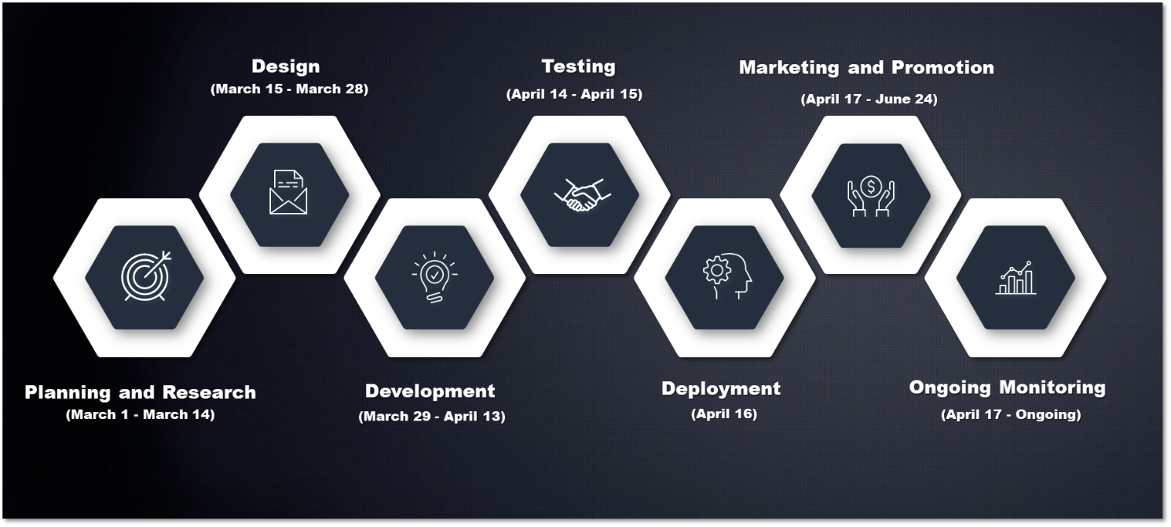

1. **Project Workflow**
2. Planning and Research: This phase typically involves defining project goals, conducting market research, and gathering requirements. It sets the foundation for the entire project.
3. Design: In this stage, the project's architecture and user interface are created. This involves wireframing, prototyping, and planning user experiences.
4. Development: This is where the actual coding and building of the project take place. Developers implement the designs and turn them into a working product.
5. Testing: After development, the product undergoes various testing phases to identify bugs and ensure it meets the requirements. This includes unit testing, integration testing, and user acceptance testing.
6. Deployment: The final stage where the product is launched to users. This may involve releasing it to a live environment and ensuring that everything functions as expected.

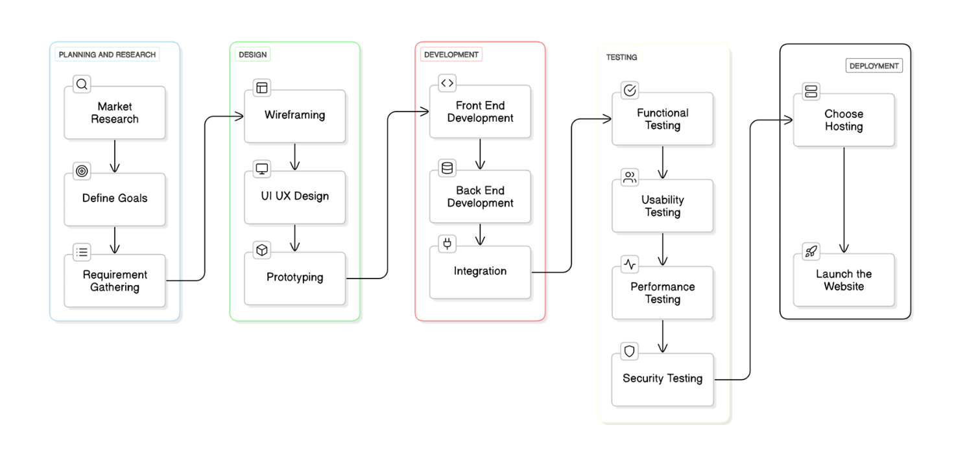

1. **Functional Requirements Specification (FRS)**

**1. Introduction**

**1.1 Purpose**

* This document specifies the functional requirements for an e-commerce website dedicated to selling eyeglasses. It aims to provide a clear framework for development, ensuring both user satisfaction and effective management for administrators.

**1.2 Scope**

* The website will include features for user account management, product browsing, shopping cart functionality, checkout processes, and administrative controls. The target audience includes general consumers looking for eyeglasses and administrators managing the website's operations.

**2. Functional Requirements**

**2.1 User Registration and Authentication**

**FR-1:** **User Registration**

* **Description:** Users can create an account to access personalized features.
* **Inputs:**
* Email address (must be unique)
* Password (minimum 8 characters, at least one uppercase letter, one number)
* First name and last name
* Phone number (optional)
* **Outputs:**
* Success message with a confirmation email link.
* **Validation:**
* Email format validation
* Password strength validation

**FR-2:** **User Login/Logout**

* **Description:** Users can log in and log out of their accounts.
* **Inputs:**
* Email address
* Password
* **Outputs:**
* Redirect to user dashboard upon successful login.
* Redirect to homepage upon logout.

**FR-3:** **Password Reset**

* **Description:** Users can reset their passwords if forgotten.
* **Inputs:**
* Registered email address
* **Outputs:**
* Email with password reset link.

**2.2 Product Catalog**

**FR-4:** **Display Products**

* **Description:** The system shall display a list of eyeglasses.
* **Outputs:**
* Product images (minimum of three views)
* Product name
* Price
* Short description
* Availability status

**FR-5:** **Product Filtering**

* **Description:** Users can filter products to find specific types.
* **Filters:**
* Frame Type (e.g., full-rim, semi-rimless, rimless)
* Gender (men, women, unisex)
* Material (plastic, metal, wood)
* Price Range (sliders for minimum and maximum)

**FR-6:** **Product Sorting**

* **Description:** Users can sort the displayed products.
* **Options:**
* Price (ascending/descending)
* Popularity
* Newest Arrivals

**2.3 Product Details Page**

**FR-7:** **Detailed Product Information**

* **Description:** Users can access detailed information for each product.
* **Outputs:**
* High-resolution images (zoom feature)
* Comprehensive description
* Specifications (dimensions, weight, lens type)
* Customer reviews and ratings
* Related products section

**FR-8:** **Add to Cart Functionality**

* **Description:** Users can add products to their shopping cart.
* **Inputs:**
* Quantity selection
* Frame color selection (if applicable)
* **Outputs:**
* Confirmation message indicating the product has been added.

**2.4 Shopping Cart**

**FR-9:** **View Shopping Cart**

* **Description:** Users can view items in their cart.
* **Outputs:**
* List of products with thumbnails, names, quantities, and prices
* Subtotal and estimated shipping cost
* Total cost

**FR-10:** **Cart Modification**

* **Description:** Users can modify items in the cart.
* **Functionality:**
* Update quantities (increase/decrease)
* Remove items
* Apply discount codes (validations for codes)

**2.5 Checkout Process**

**FR-11:** **Checkout Initiation**

* **Description:** Users can proceed to checkout.
* **Outputs:**
* Summary of items in the cart
* Option to continue shopping or proceed to checkout

**FR-12:** **Shipping Information**

* **Description:** Users must enter shipping details.
* **Inputs:**
* Full name
* Shipping address (street, city, state, zip code)
* Phone number (optional)

**FR-13:** **Payment Information**

* **Description:** Users must enter payment details.
* **Inputs:**
* Credit/Debit card number
* Expiry date
* CVV code
* Billing address (if different from shipping)
* **Outputs:**
* Confirmation of payment processing

**FR-14:** **Order Confirmation**

* **Description:** Users receive an order confirmation.
* **Outputs:**
* Order summary including order number, items purchased, total cost, estimated delivery date
* Email confirmation with tracking information

**2.6 User Account Management**

**FR-15:** **View Order History**

* **Description:** Users can view their past orders.
* **Outputs:**
  + List of previous orders with details (order number, date, status, total cost)

**FR-16:** **Profile Management**

* **Description:** Users can update their account information.
* **Inputs:**
* New shipping address
* Phone number
* Payment methods (add or remove)
* **Outputs:**
  + Confirmation message upon successful updates

**2.7 Admin Panel**

**FR-17:** **Product Management**

* **Description:** Admins can manage product listings.
* **Functionality:**
* Add new products (image upload, description, pricing)
* Edit existing product details
* Remove products from the catalog

**FR-18:** **Order Management**

* **Description:** Admins can manage customer orders.
* **Outputs:**
  + View all orders with details (customer information, order status)
  + Update order status (processing, shipped, delivered, canceled)

**FR-19:** **Sales and Inventory Reports**

* **Description:** Admins can generate reports.
* **Outputs:**
  + Sales reports (daily, weekly, monthly)
  + Inventory status (low stock alerts)

**2.8 Search Functionality**

**FR-20:** **Search Products**

* **Description:** Users can search for specific eyeglasses.
* **Inputs:**
  + Keywords related to the product
* **Outputs:**
  + Search results list with relevant products

**2.9 Responsive Design**

**FR-21:** **Mobile Compatibility**

* **Description:** The website shall be responsive.
* **Requirements:**
* Adapt layout for mobile devices
* Ensure all functionalities (browsing, cart, checkout) are accessible on mobile

**2.10 Testing and Quality Assurance**

**FR-22:** **Testing Protocols**

* **Description:** The system shall undergo rigorous testing.
* **Types of Testing:**
  + **Unit Testing:** Test individual components for expected outputs.
  + **Integration Testing:** Ensure all components work together seamlessly.
  + **User Acceptance Testing (UAT):** Gather feedback from actual users to identify usability issues.

**3. Non-Functional Requirements**

**3.1 Performance**

* The website shall load within 3 seconds on standard broadband connections.

**3.2 Security**

* All sensitive data must be encrypted using SSL.
* Implement secure payment processing through PCI-compliant service providers.

**3.3 Usability**

* The interface shall follow design best practices to ensure an intuitive user experience.
* Accessibility standards (WCAG 2.1) must be met to accommodate users with disabilities.

**3.4 Compatibility**

* The website shall function correctly on major browsers (Chrome, Firefox, Safari, Edge) and mobile devices (iOS and Android).

1. **Website High-level Design**
2. **Site Map**

* The Optica eyeglasses online Shop website has considered layout of web pages, responsiveness, color, format, font and Logo.
* The website has incorporated key functions for online Eyeglasses order and purchase, including:
* Home page for product information and navigation
* Product Details, Shopping Cart, Place Order
* Login / Register
* About Us, Contact
* Behind the Scenes: About Eyeglasses, Making Glasses, Tips for Buying Sunglasses
* Customer Support: Terms of Reference, Privacy Policy, Goods Return Policy

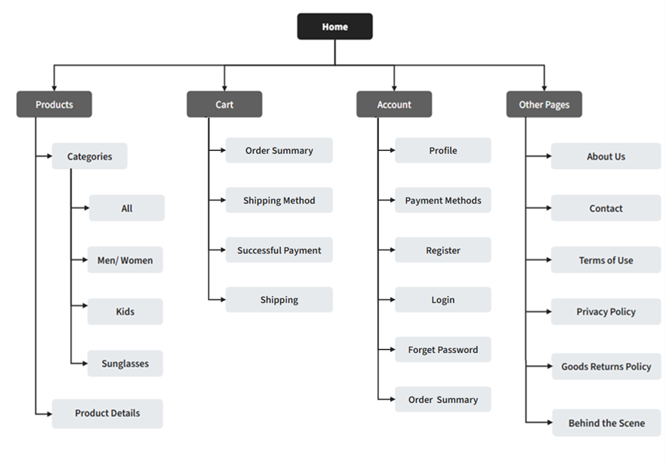

1. **Wireframe**

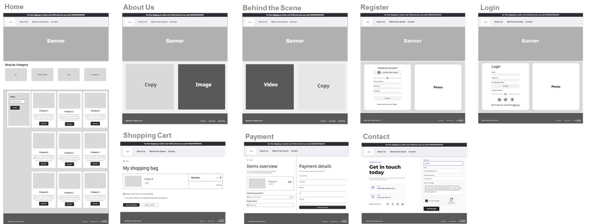

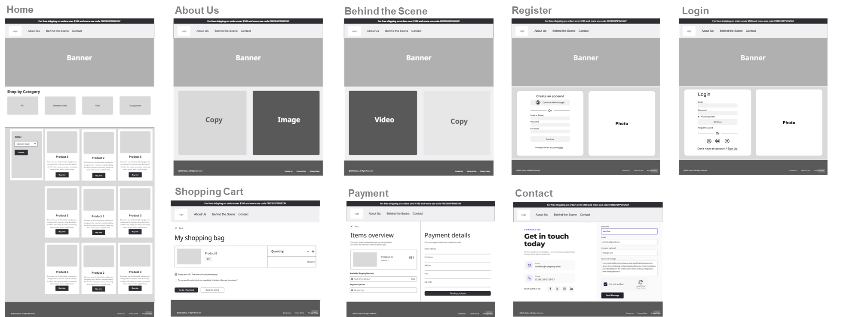

1. **Style Guide**

**Reasons for Using This Color Combination**

* Enhanced Readability: The contrast between dark shades and white improves text legibility, ensuring users can easily read product descriptions and navigation elements.
* Timeless Appeal: Neutral colors have a classic quality that withstands changing design trends, making the brand more enduring and less likely to appear outdated.
* Emphasis on Product Quality: A subdued palette allows the products to stand out without overwhelming the viewer, highlighting their quality and craftsmanship.
* Brand Differentiation: In a market often dominated by bright colors, a muted palette can differentiate the brand, positioning it as sophisticated and unique.
* Psychological Impact: The combination of dark and light tones can evoke feelings of security and calm, creating a positive shopping experience for customers.
* Flexibility in Marketing: The versatility of the color palette allows for easy integration into various marketing materials, from digital ads to print, maintaining brand consistency.

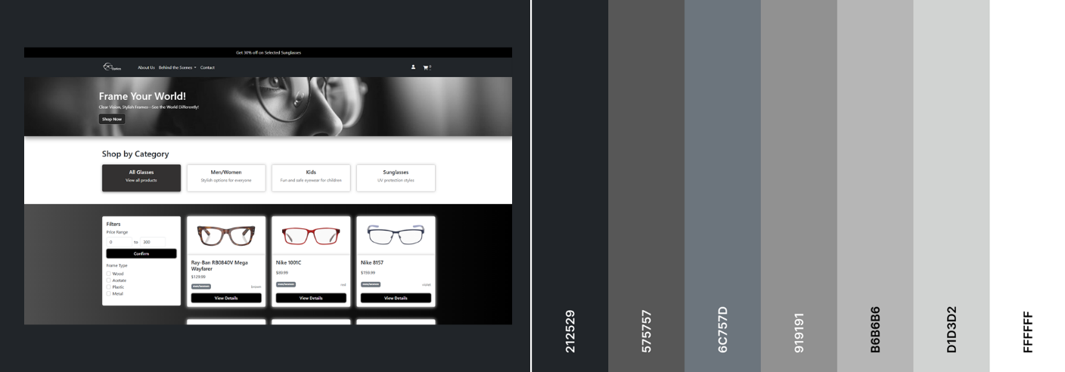

1. **Typography Style**

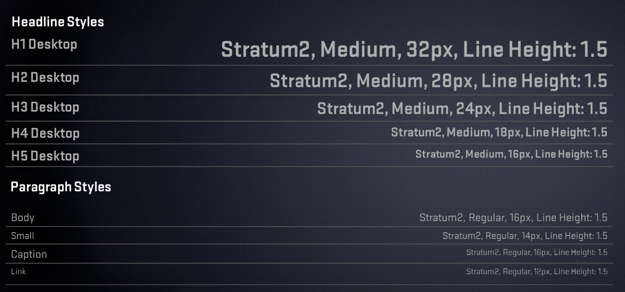

1. **High Fidelity Prototyping**High fidelity prototyping plays a crucial role in the design and development process for several reasons:
2. **Realistic User Experience**: These prototypes closely resemble the final product, providing users with an authentic interaction experience. This realism encourages more genuine feedback and helps users visualize how the final product will function.
3. **Detailed Feedback**: High fidelity prototypes allow for the collection of specific, actionable insights. Users can identify usability issues and provide feedback on design elements that may not be apparent in lower fidelity versions.
4. **Stakeholder Communication**: They effectively convey design concepts to stakeholders, making it easier to gain approval. A polished prototype helps align team members and stakeholders around a shared vision.
5. **Usability Testing**: High fidelity prototypes facilitate thorough testing of user flows and interactions. They enable the collection of meaningful usability metrics, such as task completion rates and satisfaction scores, which can guide design improvements.
6. **Design Validation**: These prototypes help validate design decisions and assumptions before development begins. They provide a basis for making informed adjustments based on user feedback.
7. **Final Design Specifications**: High fidelity prototypes serve as a detailed reference for developers, ensuring that the final product aligns with the intended design. They also provide documentation that can be valuable for future projects or iterations.
8. **Marketing and Presentation**: They can be used in marketing campaigns and investor presentations, showcasing the product in a compelling way. High fidelity prototypes are instrumental in pitching ideas to potential clients or investors.

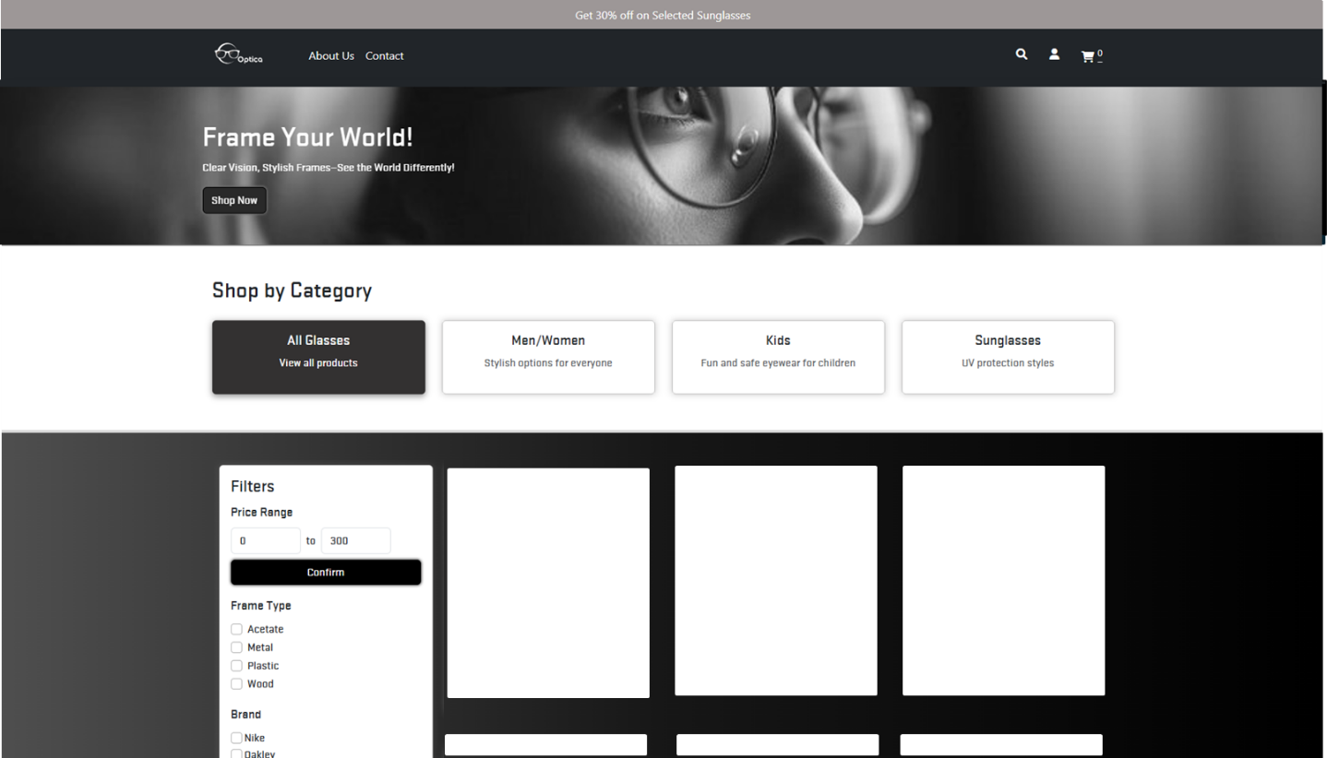

1. **System Architecture**
2. User Interaction

* Web Client (HTML5):
* Users access the application through a web interface built with HTML5.
* Mobile Client:
* Users can also interact with the system via a mobile application.

1. Authentication Process

* HTTP Requests:
  + Users send HTTP requests to the authentication service to log in.
* Authentication Service:
* This service verifies the user's credentials (username/password).
* Upon successful verification, it generates and returns an authentication token.

1. API Communication

* API Gateway:
* The application uses an API gateway to route requests to the appropriate services.
* It applies business logic to determine which service to call based on the request.

1. Order Processing

* Order Management:
* The application processes user orders through an order processing service.
* This service handles the creation, updating, and status tracking of orders.

1. Inventory Management

* Inventory Service:
* Manages product availability and stock levels.
* Interacts with the order processing service to adjust inventory based on orders.

1. Database Interaction

* User Database:
* Stores user profiles, authentication tokens, and related information.
* Inventory Database:
* Maintains records of products, including stock levels and descriptions.

1. Payment Handling

* Payment Processor API:
* Integrated to manage payment transactions securely.
* Handles credit card processing and other payment methods.
* Fraud Detection:
* Implemented to monitor transactions for fraudulent activity.
* Works in conjunction with the payment processor to ensure security.

1. Backend Services

* Microservices Architecture:
* The system may utilize microservices architecture, separating different functionalities into distinct services.
* Scalability:
* Each service can be scaled independently based on demand.

1. Overall Flow

* The user initiates actions (e.g., placing an order) via the web or mobile client.
* The requests are authenticated and processed through various services.
* The system efficiently manages data through its databases, ensuring a seamless user experience.

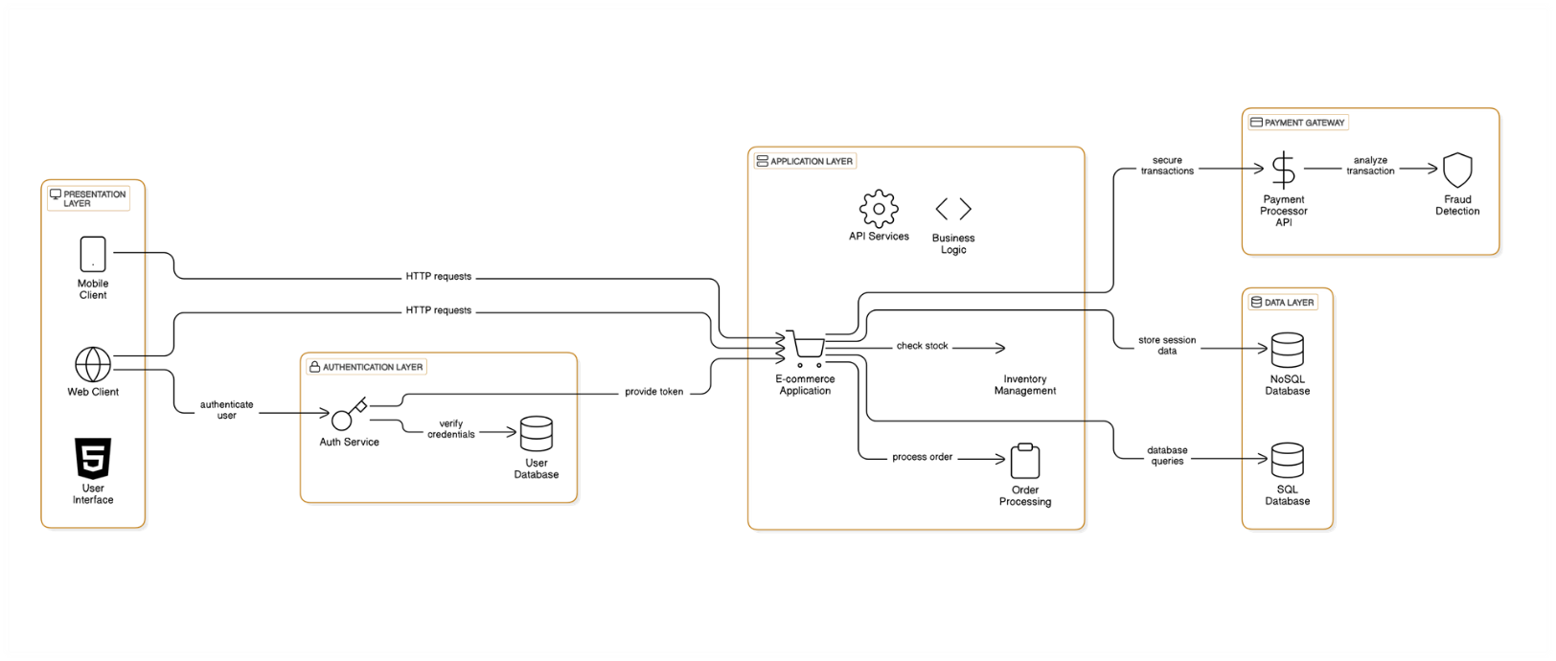

1. **Testing and Refinement**

|  |  |
| --- | --- |
| **Unit Test** | * validate user’s input (e.g. order quality) * validate add/remove of orders * check calculation on total price (e.g. price * quality) * check user email address and password format |
| **Functional Test** | * test all user flows (browsing, shopping cart, checkout) * test filtering on frames |
| **User Acceptance Test (UAT)** | * develop UAT test plan that includes testing approach, resources required, timelines and responsibilities. * prepare test cases, each test case has acceptance criteria |
| **Responsiveness** | * test on response time and responsiveness on different devices |
| **Collect Feedback and Report Issues** | * gather feedback from UAT participants regarding usability, functionality and any issues. * document any defects or issues found, including severity and steps to reproduce them, and organize them into tracking record. |
| **Refinement** | * through regular review and discussion within the team, several suggestions have been made to improve user friendliness, responsiveness and to ease navigation of the website. |
| **Integration Testing (SIT)** | * test if the payment gateway (Stripe) correctly processes orders from the shopping cart. * synchronization of inventory updates after a purchases |

1. **Key Web Pages Information**

* **Page Name: Home**
* Home Page for customers’ entry to online shop
* Visual information about company products and services
* When click “Shop Now”, it will take customer to shopping selection by Categories (Men/Women, Kids, Sunglasses), with filtering option by price range and frame type
* Provide navigation bar to other web pages
* Display customer’s login and order summary
* Program: index.html

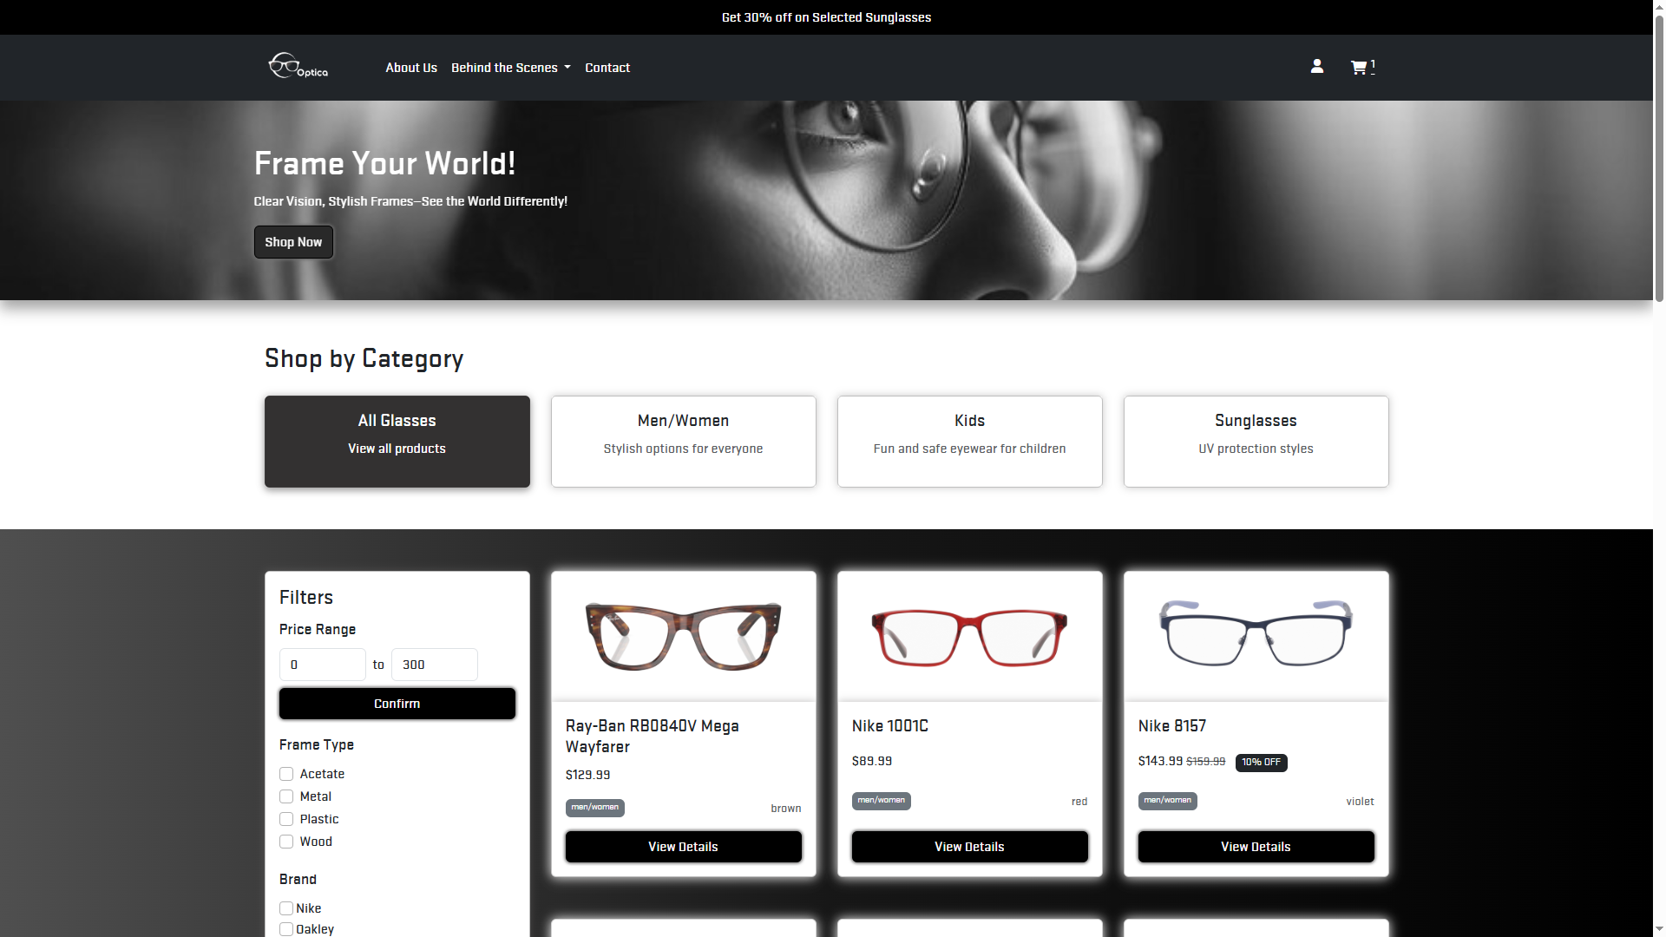

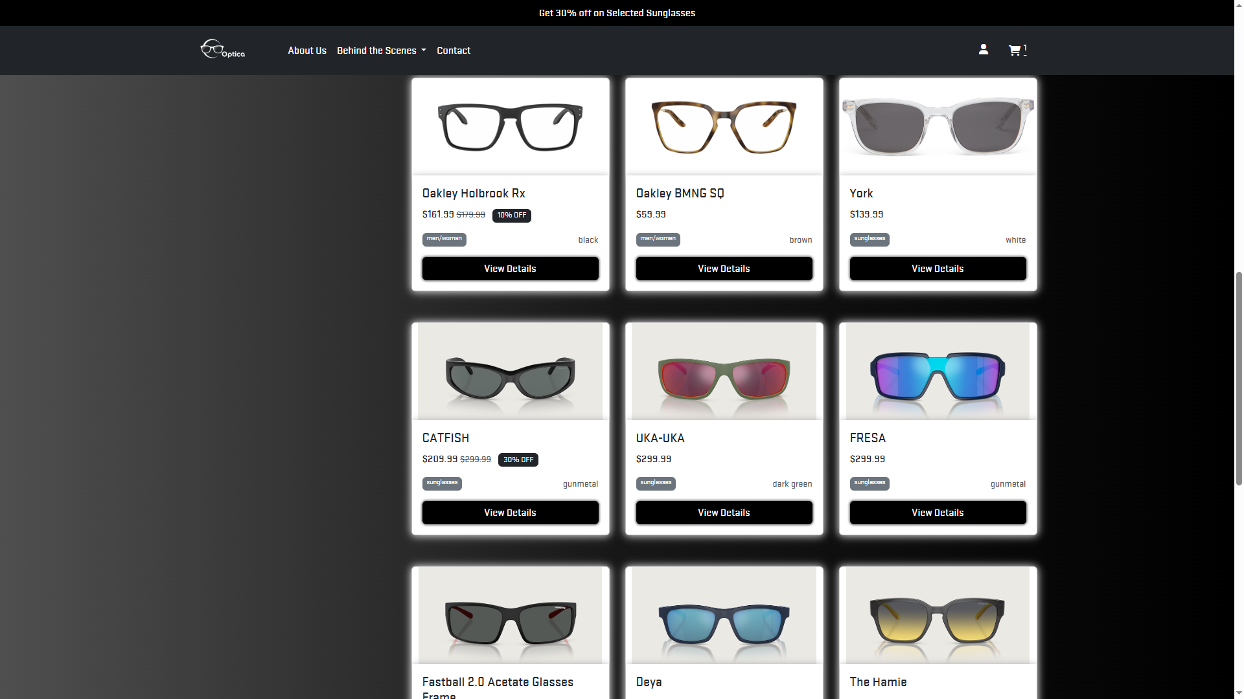

* **Page Name: Product Details**
* Details of customer selected product
* Model, Brand
* Price
* Description
* Frame Type, Color
* Quantity for customer input
* Customers to confirm order placed by adding to Shopping Cart
* Program: products.json

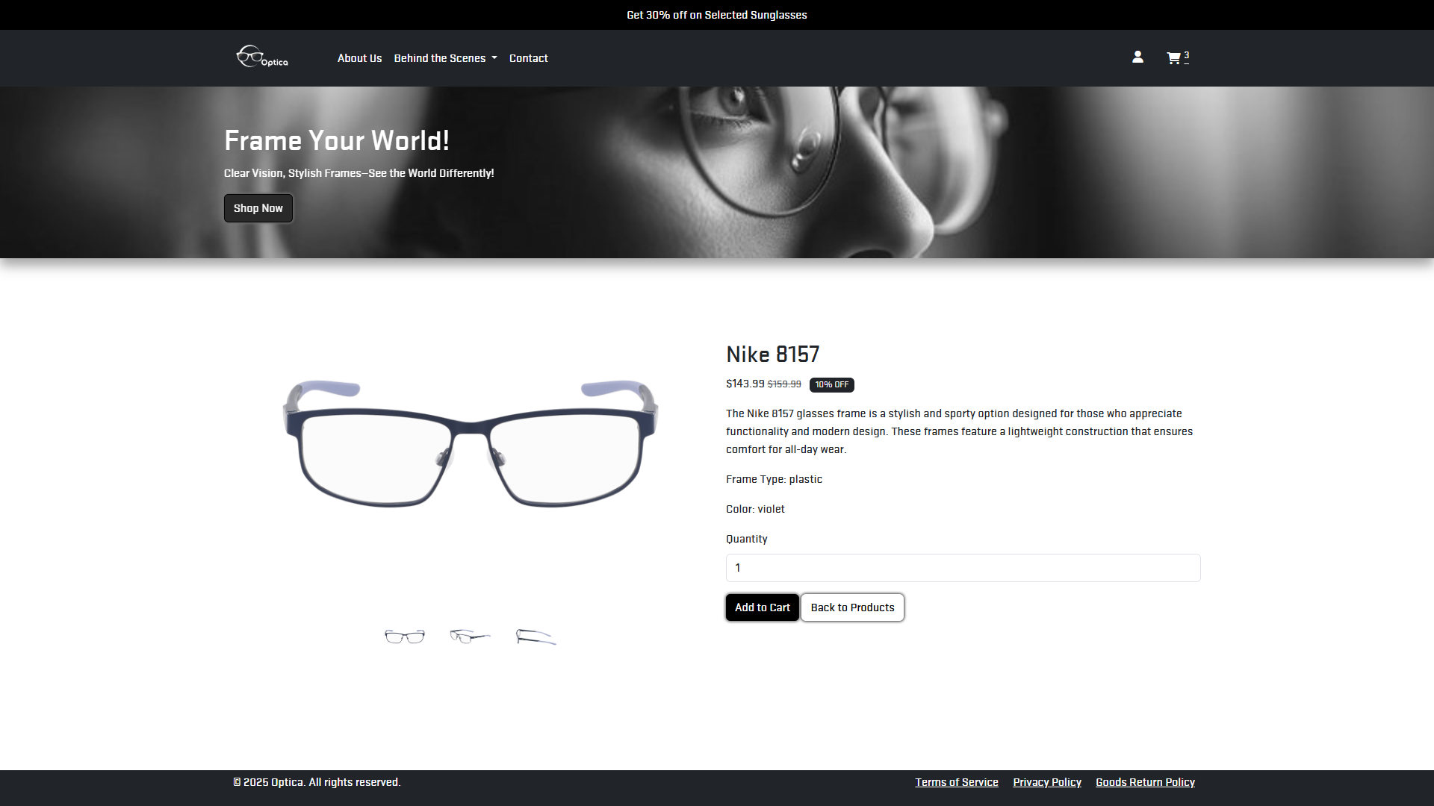

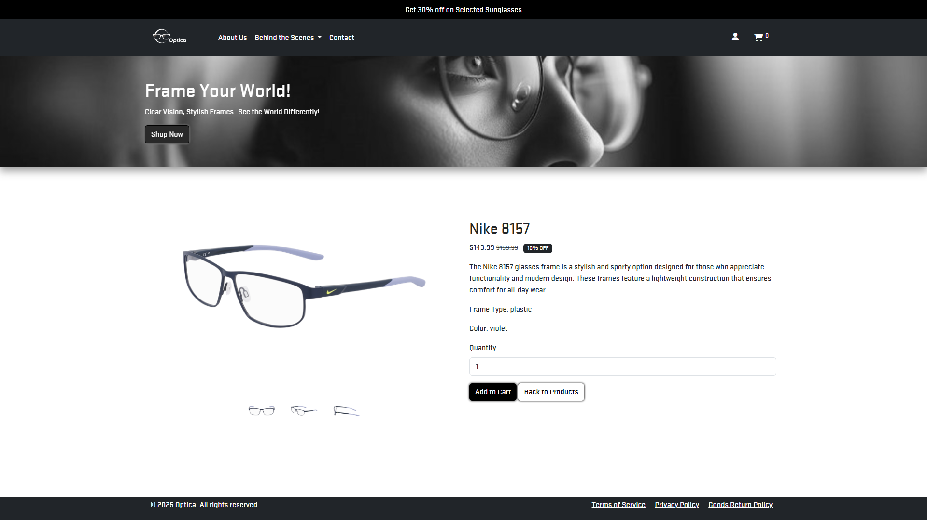

* **Page Name: Shopping Cart**
* Display all items selected by customers, with model, quantity and total price
* Customer review on ordered products and quantity
* Customer can proceed to place their order
* Order cancellation is allowed
* Program: cart.js

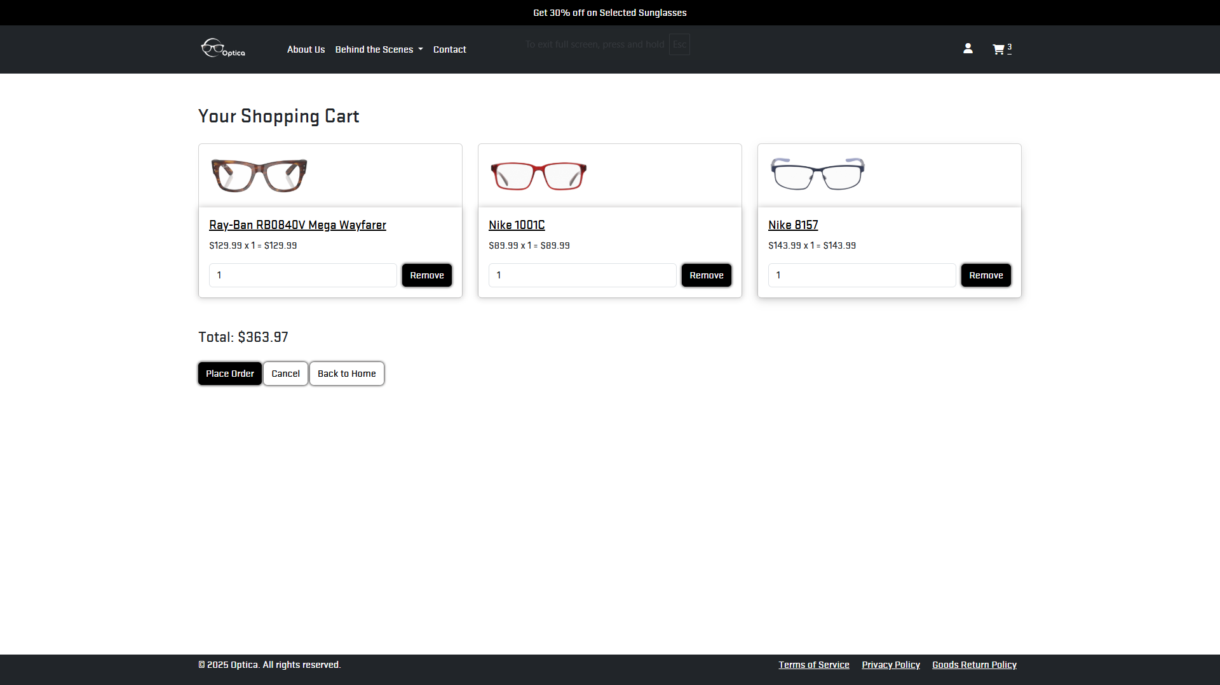

|  |  |
| --- | --- |
|  |  |

**Registration**

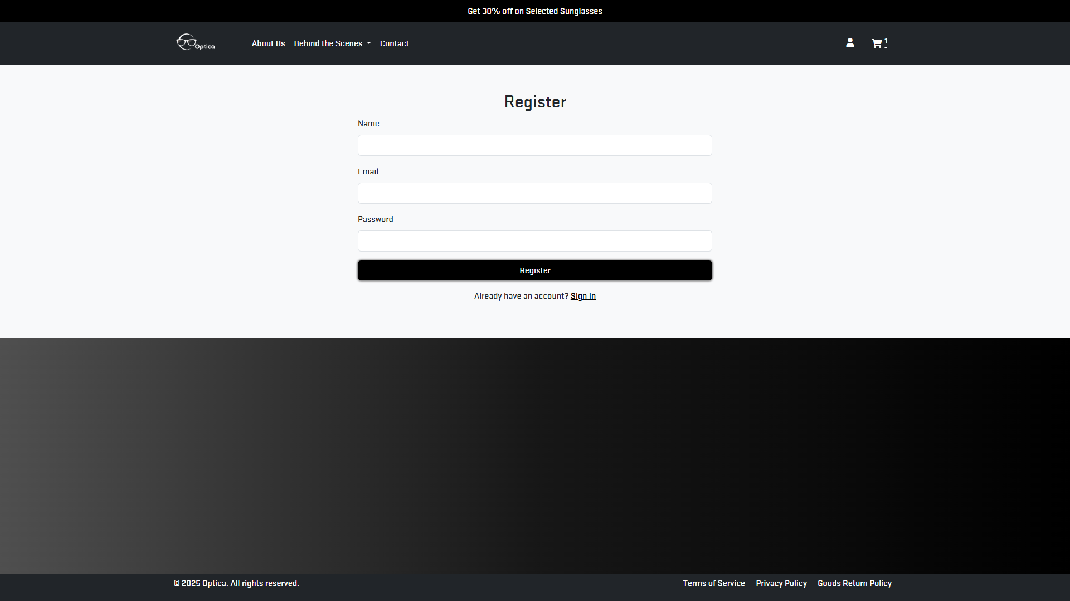

**Login**

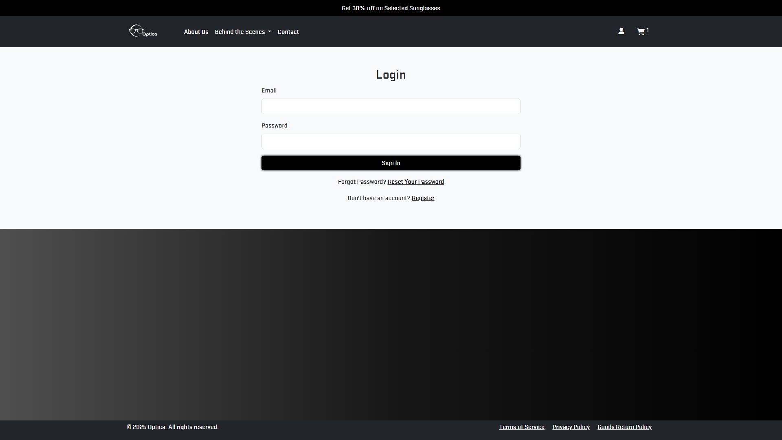

**Forget Password**

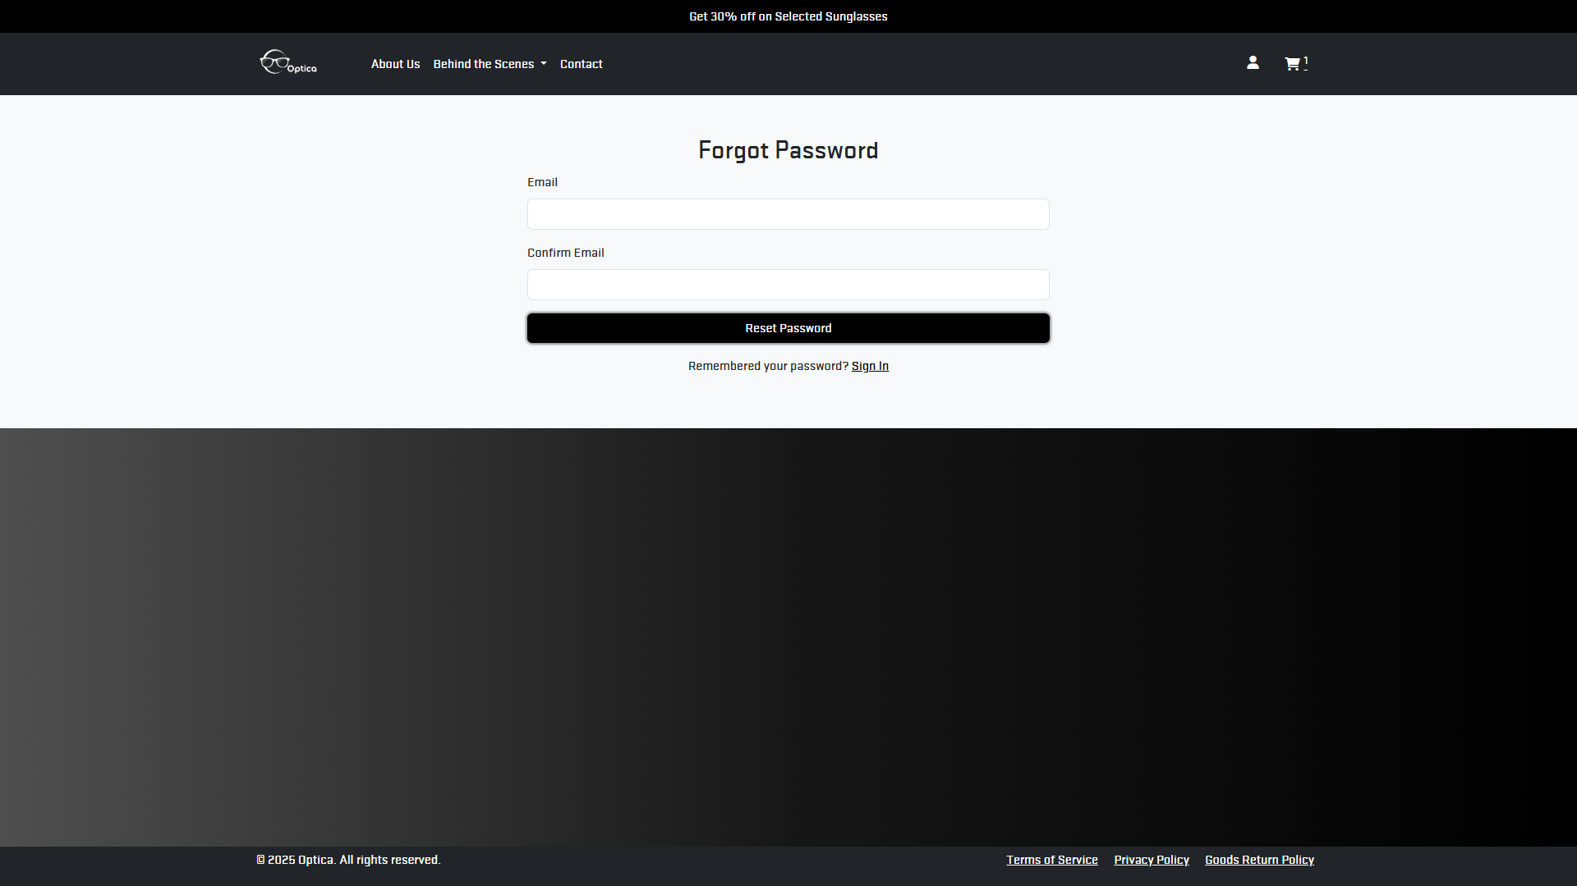

**About Us**

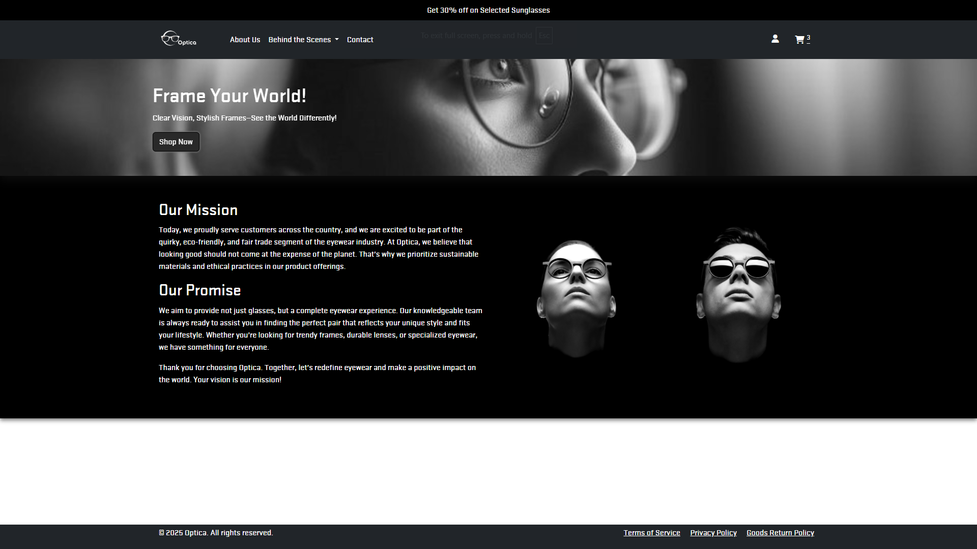

**Contact Us**

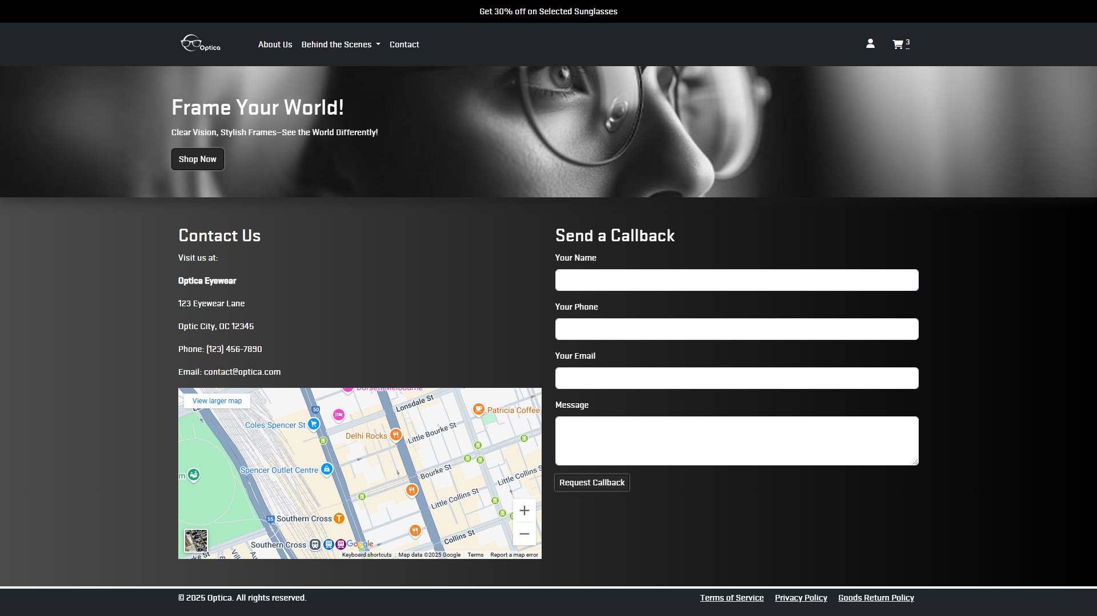

**Terms of Services**

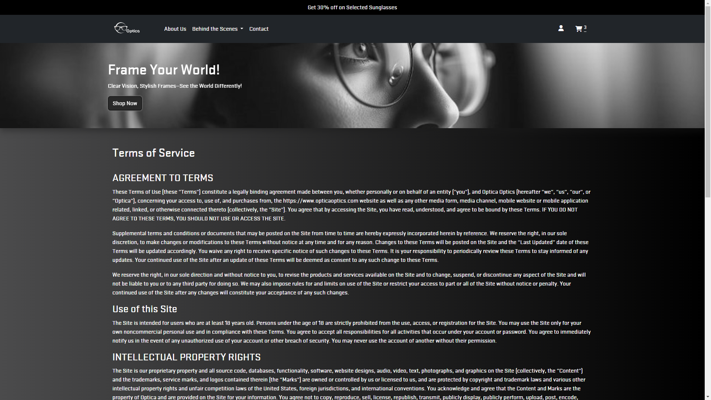

**Privacy Policy**

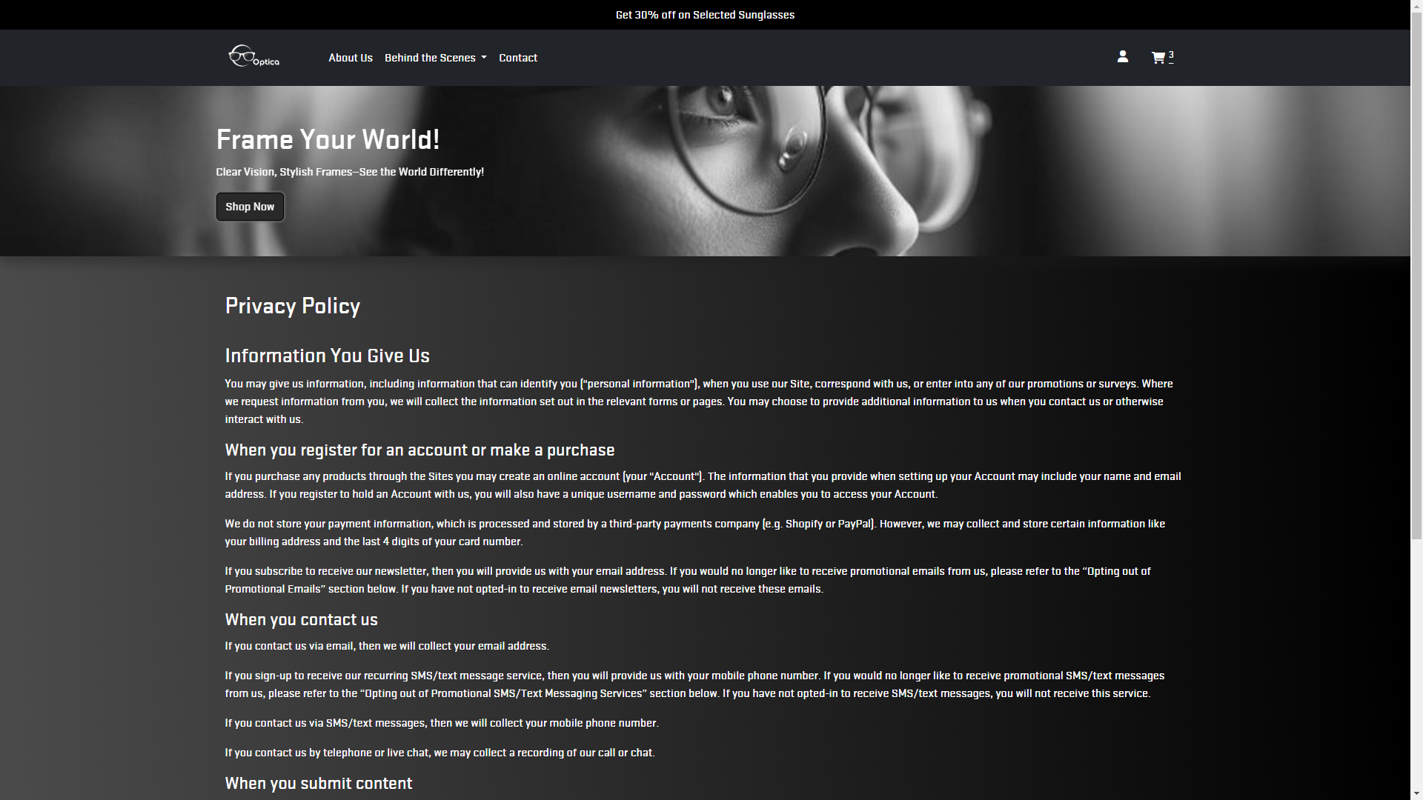

**Behind the Scene: What are Eyeglasses**

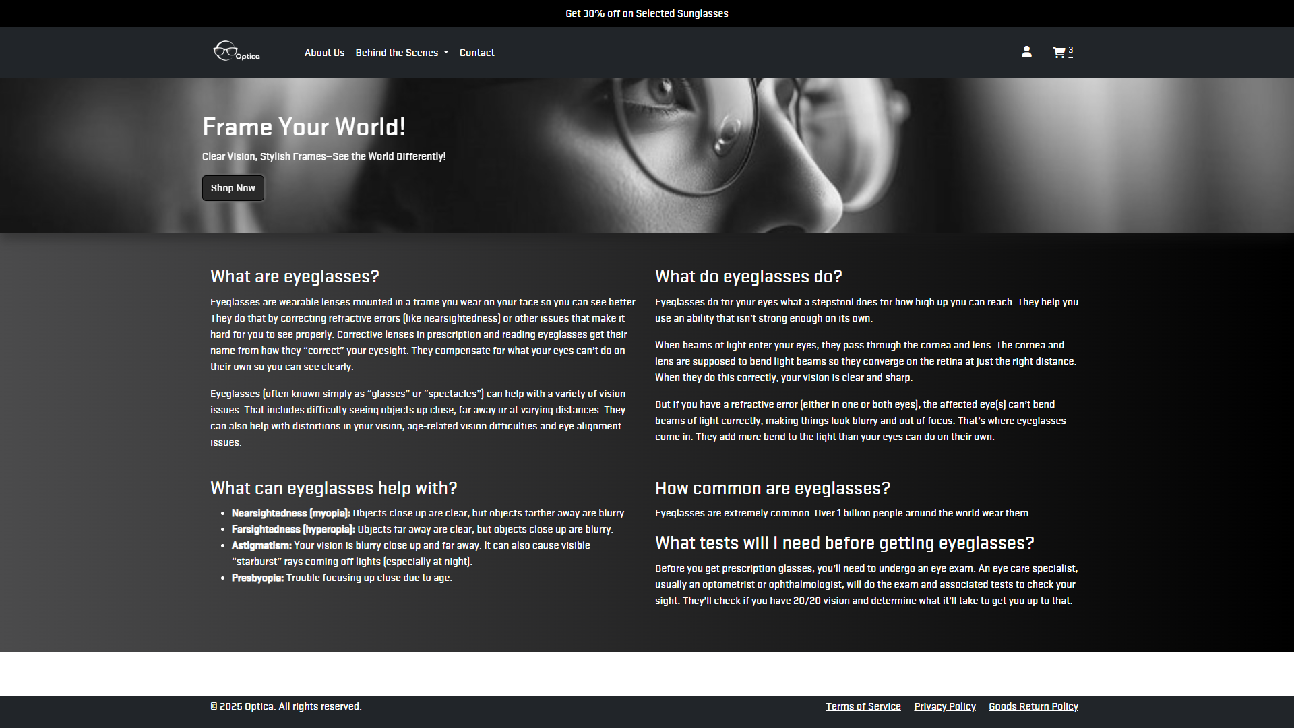

**Behind the Scene: Making Glasses**

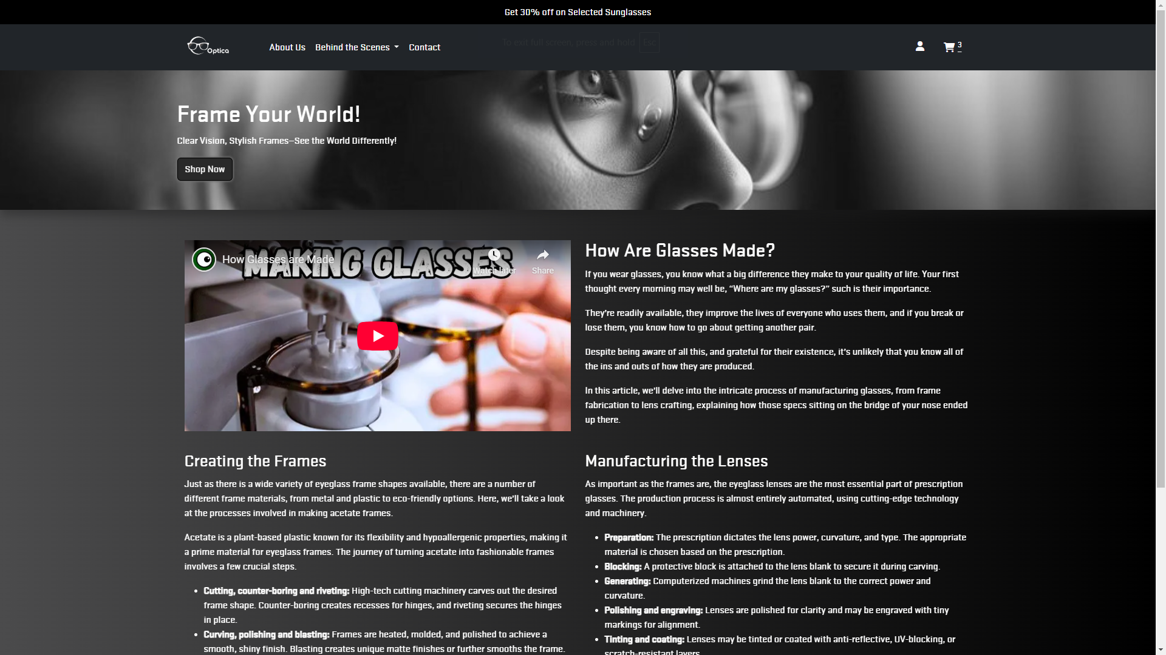

**Behind the Scene: Buying Glasses**

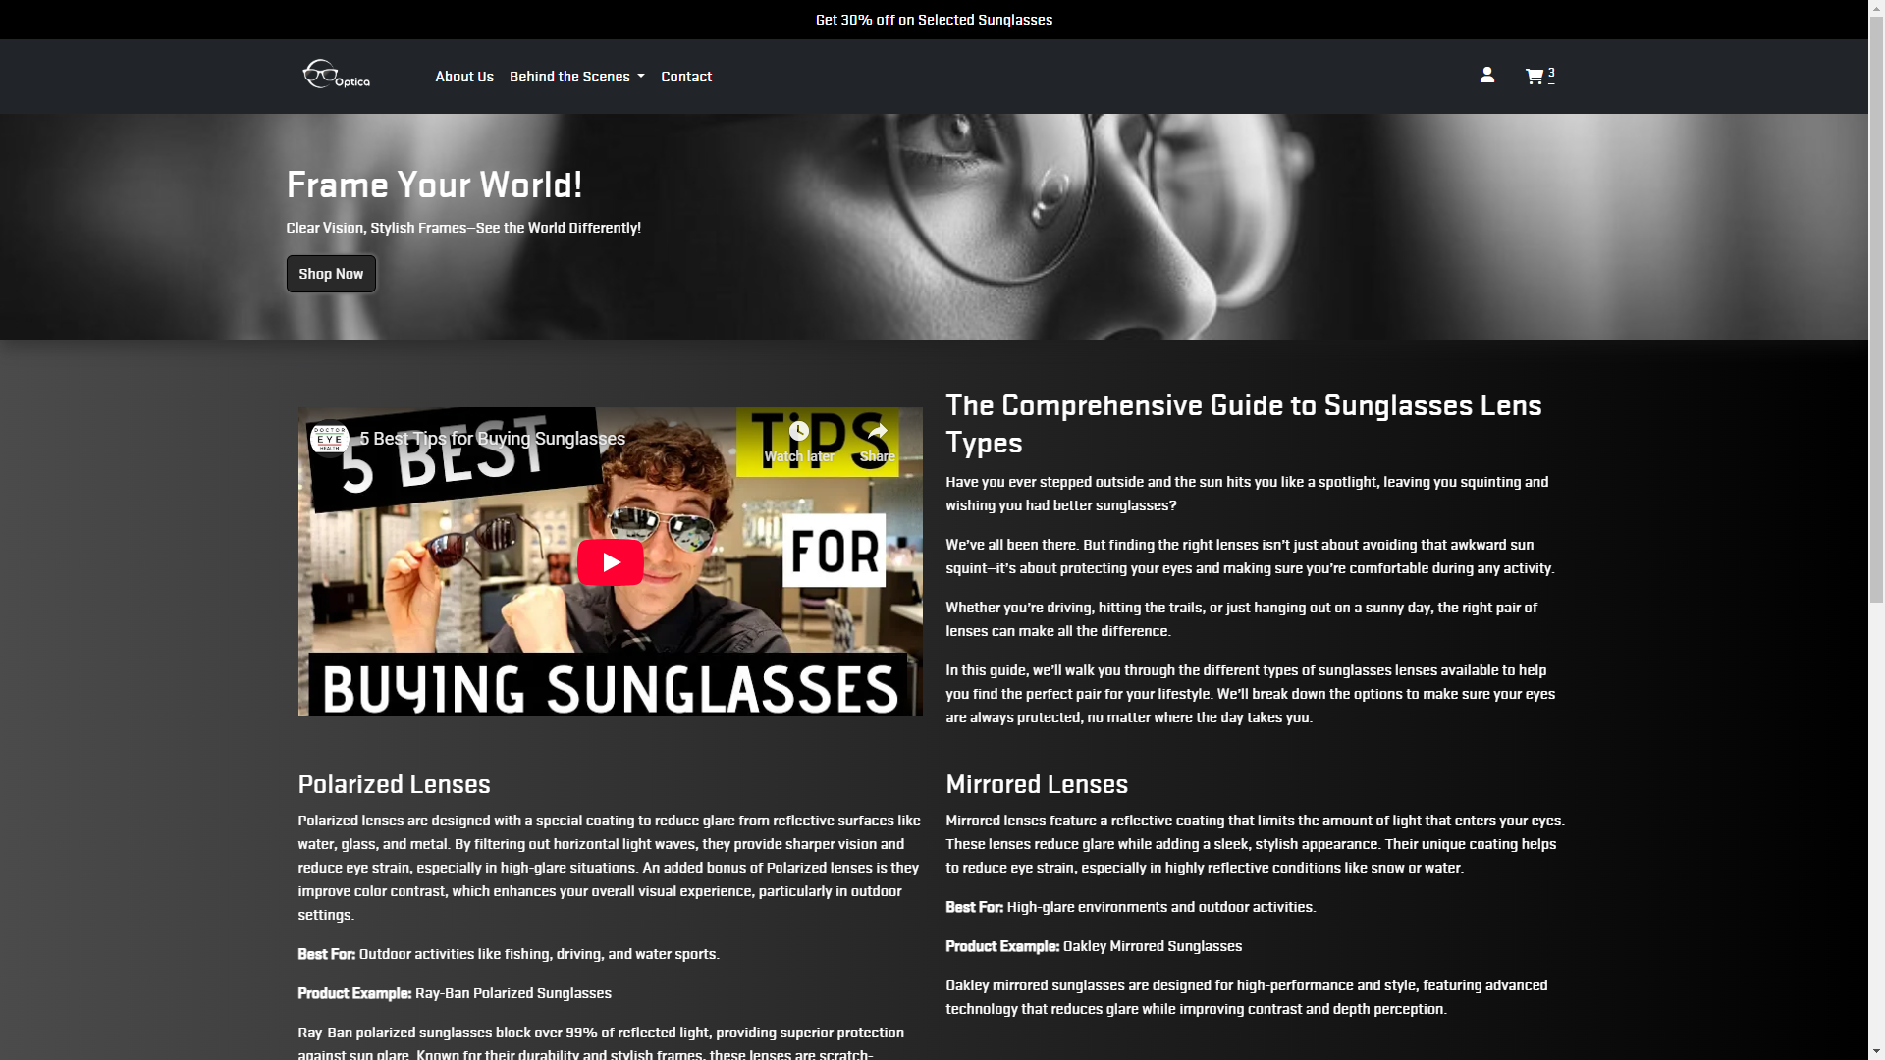

1. **Responsive Design**

Responsive design allows a website to adapt its layout and content to different screen sizes and devices.

* Key Features
* Fluid Grids: Uses proportional sizing for flexible layouts.
* Flexible Images: Images scale with containers to fit various screens.
* Media Queries: CSS rules that apply styles based on device characteristics.
* Viewport Meta Tag: Controls layout scaling on mobile devices.
* Benefits
* Improved User Experience: Enhances accessibility and engagement on all devices.
* SEO Advantages: Boosts visibility and ranking in search results.
* Cost-Efficiency: Reduces the need for multiple site versions.
* Faster Development: Streamlines the design and update process.
* Futureproofing: Adapts to new devices and screen sizes.

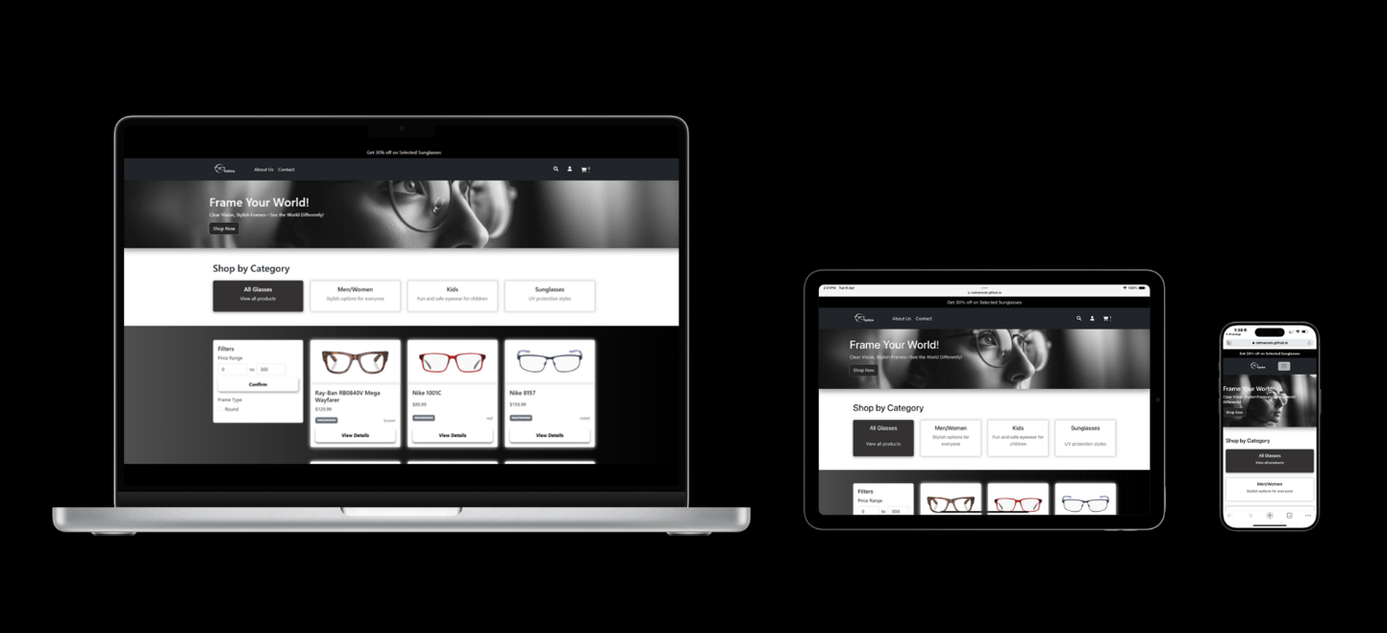

1. **Learning Outcomes**

* Teamwork: Gained valuable insights into the dynamics of working collaboratively, enhancing communication and problem-solving skills.
* Research Skills: Developed the ability to conduct effective market research to inform design choices and identify gaps in the market.
* Technical Skills: Improved proficiency in web development technologies and eCommerce platforms.
* User Experience Focus: Learned the significance of creating an interactive and user-friendly interface to enhance customer satisfaction.

1. **Conclusion**

* The "Optica" Eyeglasses online store project successfully created a responsive and user-friendly eCommerce website.
* The team effectively differentiated the site from existing competitors through unique design and features.
* The project highlighted the importance of thorough research and collaboration in achieving project goals.